System Architecture
The system architecture serves as a blueprint for the physical deployment of the system. It illustrates how the users, the web server, the database server and the photo storage of the implemented system are connected to one another.
Figure 11 shows the system architecture of the Digital Broodcock Farm Record Management System.

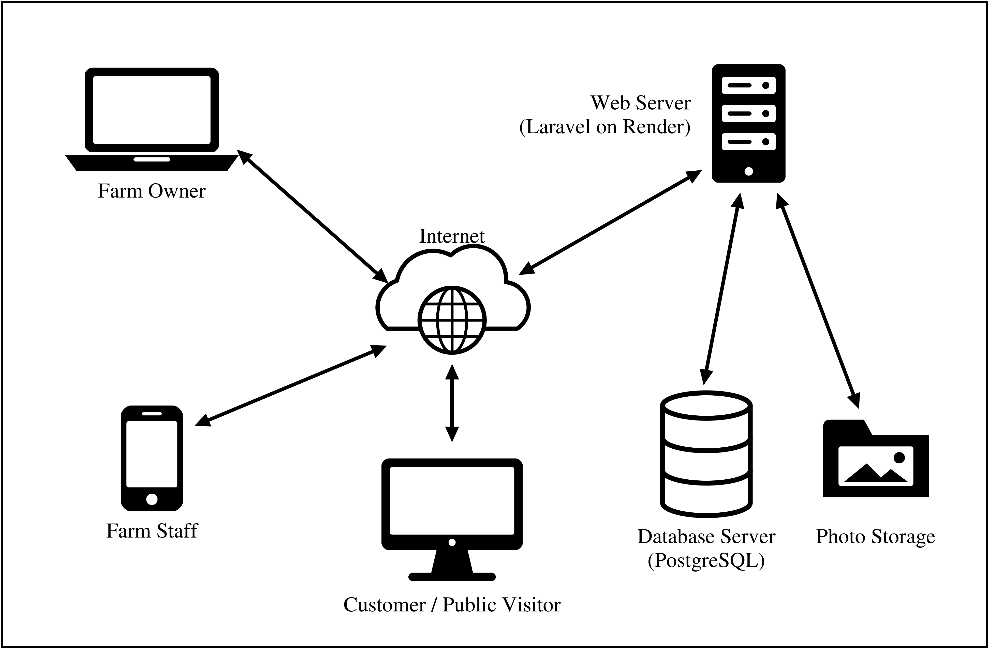
Figure 11. System Architecture

The system architecture of the Digital Broodcock Farm Record Management System is web based, so no application has to be installed on any device. The farm owner, the farm staff, and customers or public visitors open the system through a web browser on a laptop, a desktop computer or a mobile phone, and every request travels over the Internet to a single web server.
The web server, a Laravel application hosted on Render, acts as the hub of the system: it receives each request, checks the user’s role before anything is shown or saved, and returns the page. The farm owner manages user accounts, farm settings and reports; the farm staff record broodcocks, matings, health treatments, performance and mortality, mostly from their phones while working on the farm; and customers or public visitors may view only the public catalogue, each bird’s page and its family tree. Behind the web server, the database server (PostgreSQL) holds every farm record, and a separate photo storage holds the photographs of the birds. Neither is reachable by users directly: all reading and writing passes through the web server, which keeps the records secure and consistent while allowing the farm to be managed from any location with an Internet connection.

